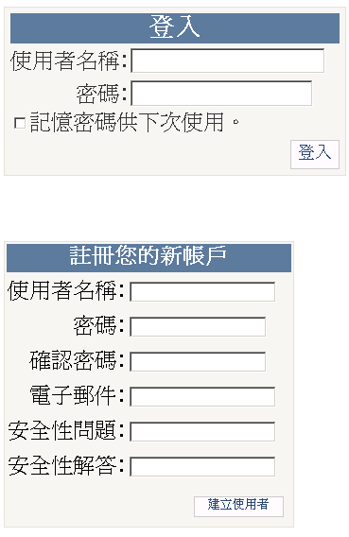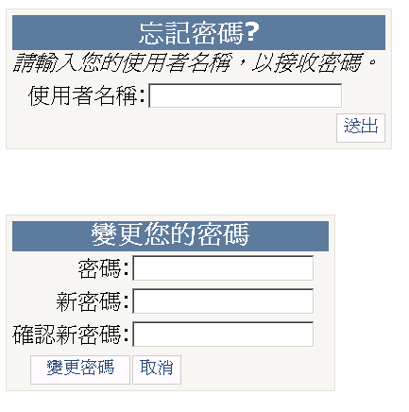

MyMember Class
Property

Method
.. CreateUser(string username, string password);

.. CreateUser(string username, string password, string email);

… ValidateUser(string username, string password);

//=======================

DeleteUser(….
FindUsersByEmail( ….
ChangePassword ….

